 

**Placement Empowerment Program**

***Cloud Computing and DevOps Centre***

Create a storage platform to store file or download files

Name: Lakshmi Priya P

Department: ECE



**Introduction**

In this guide, we will walk through the process of creating a bucket in Amazon Simple Storage Service (S3) using the AWS Management Console. S3 is a scalable object storage service that allows you to securely store and retrieve data, such as documents, images, and backups. Buckets are containers for organizing and storing your data in S3. This task will cover the basic steps to set up a new bucket, configure essential settings, and upload files for storage

**Overview**

The task involves creating an Amazon S3 bucket using the AWS Management Console. Amazon S3 (Simple Storage Service) is a cloud storage solution that allows users to store and manage large amounts of data securely. In this task, you will learn how to:

1. **Create a New Bucket**: Set up a new S3 bucket with a globally unique name and choose an appropriate AWS region.
2. **Configure Bucket Settings**: Understand and configure options like versioning, public access settings, and other permissions.
3. **Upload Files**: Learn how to upload files into the created bucket for storage.

This process is essential for anyone looking to store data in the cloud, whether it’s for backups, file sharing, or application data storage. By following the steps, you will be able to create a secure and organized storage system in AWS S3.

**Objectives**

1. **Understand S3 Buckets**: Learn about Amazon S3, its purpose, and how buckets are used to organize and store data in the cloud.
2. **Create a New S3 Bucket**: Gain hands-on experience in creating a new S3 bucket in the AWS Management Console, ensuring proper naming conventions and region selection.
3. **Configure Bucket Settings**: Set up essential configurations such as permissions, access controls, and versioning to ensure the bucket meets security and management requirements.
4. **Upload Files to S3**: Learn how to upload files into the created bucket and manage the storage of those files.
5. **Ensure Security Best Practices**: Understand how to implement best practices for data security, such as blocking public access to the bucket and using appropriate access controls.

**1. Log in to AWS Management Console**

* Open your web browser and navigate to the [AWS Management Console](https://aws.amazon.com/console/).
* Enter your credentials (email and password) and log in.

**2. Navigate to S3 Service**

* Once logged in, find the **"Services"** menu at the top of the page.
* Type **"S3"** in the search bar and select **S3** from the list of services

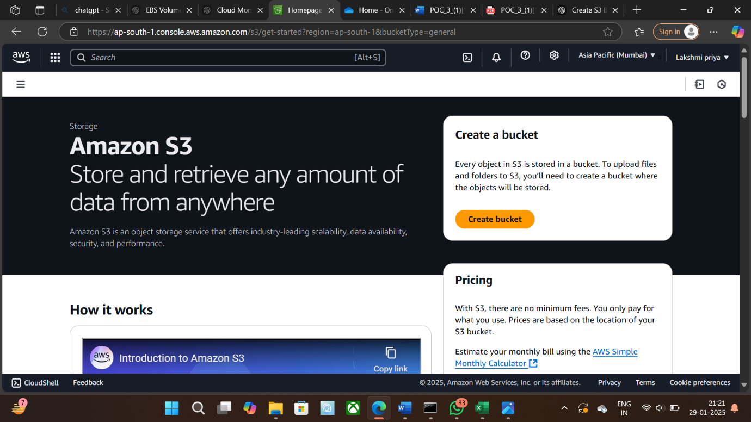

**3. Create a New Bucket**

* In the S3 dashboard, click on the **"Create bucket"** button.

. 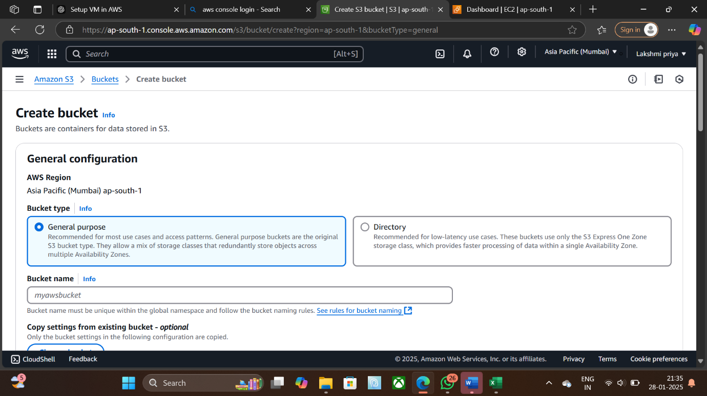

**4.Configure Bucket Settings**

* **Bucket Name**: Enter a globally unique name for your bucket (e.g., my-unique-bucket-name-123).
  + Bucket names must be unique across all of AWS and adhere to certain naming rules:
    - Lowercase letters, numbers, hyphens (-).
    - Must start and end with a letter or number.
    - No spaces or uppercase letters.
* **Region**: Select an AWS region where you want to store the bucket (e.g., US East (N. Virginia) us-east-1). This should be geographically close to your target audience or application for better performance.

**5.Set Permissions**

* If you need to grant permissions to specific users or groups, you can set those permissions here.
* By default, the bucket is private, and only the owner can access it unless permissions are specifically added.
* Make sure **Block all public access** remains enabled unless you want your bucket to be publicly accessible

**6. Review and Create Bucket**

* Review your settings. If everything looks good, click the **"Create bucket"** button at the bottom of the page
* 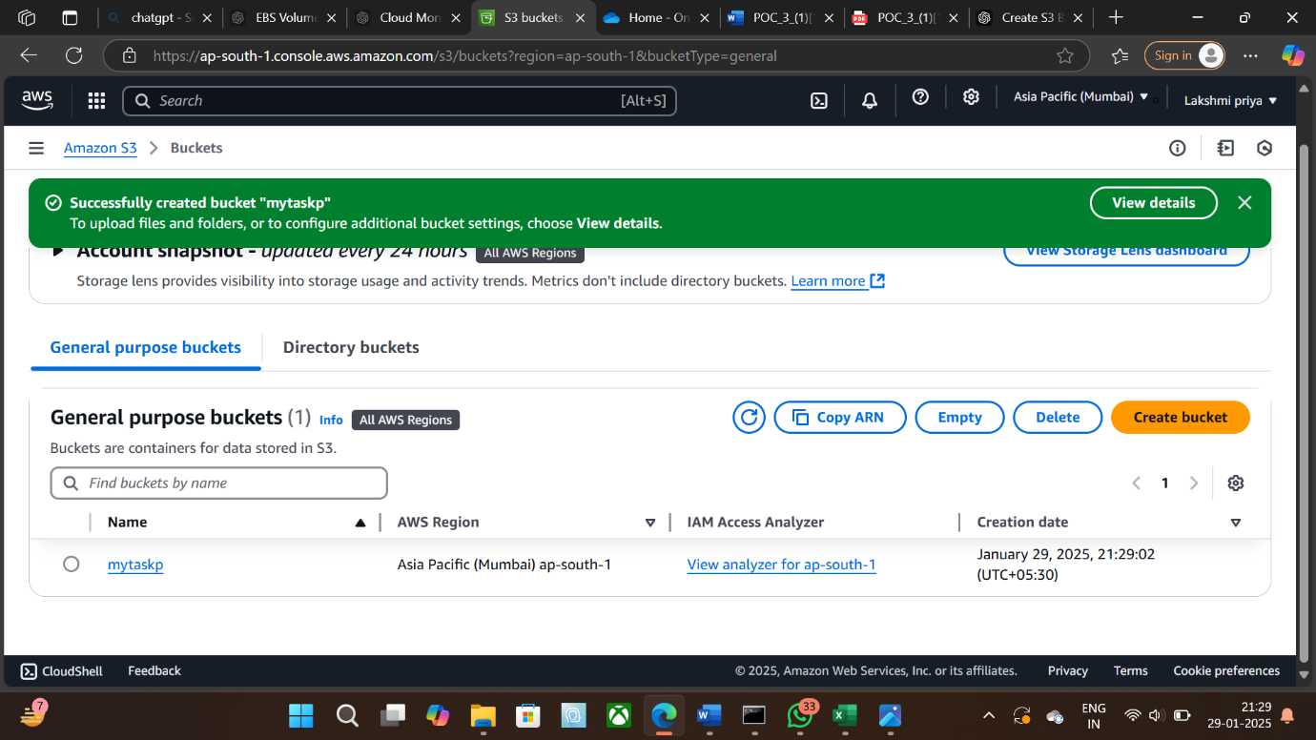

**7. Bucket Created**

* After a few moments, your bucket will be created successfully. You’ll be redirected to the **S3 Dashboard** where your new bucket will now appear in the list.

**8. Upload Files to Your Bucket**

* Select the newly created bucket from the list.
* Click on the **"Upload"** button.
* Drag and drop the files you want to upload or browse your system to select them.
* After selecting the files, click **"Upload"** to store them in the bucket

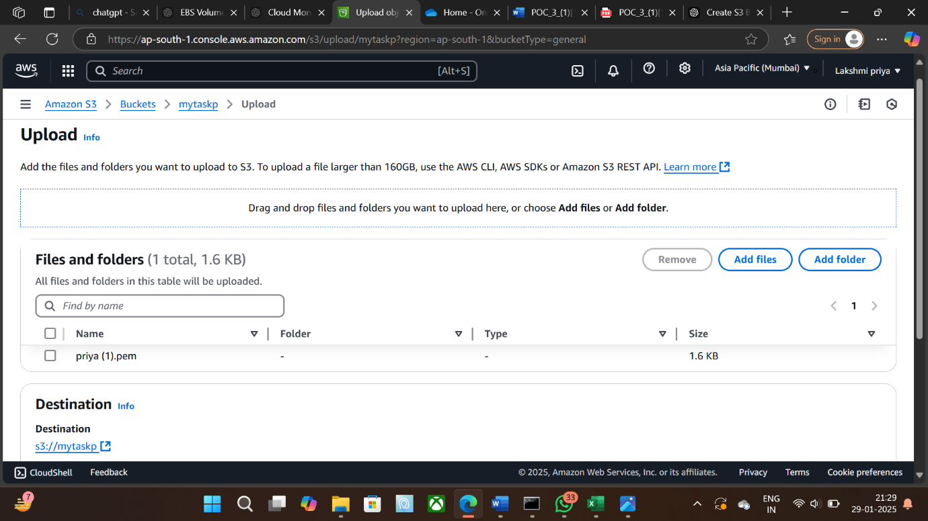

9.Change the bucket policies with the code.

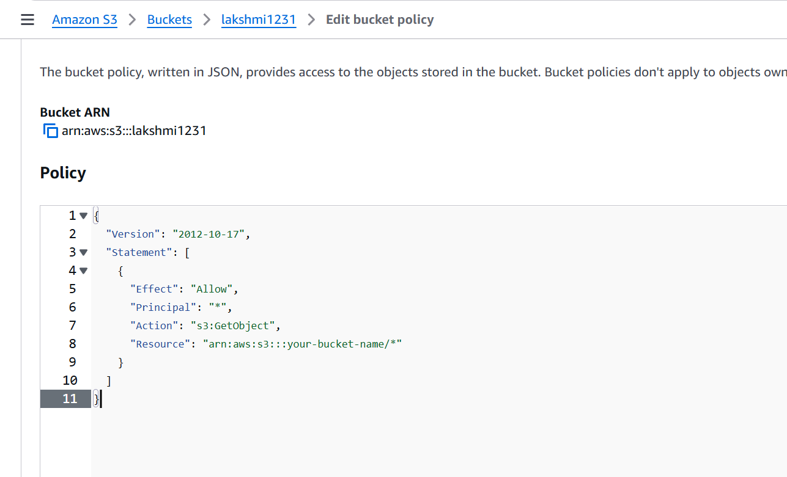

10.Select the buckets and copy the URL and paste it in the chrome.

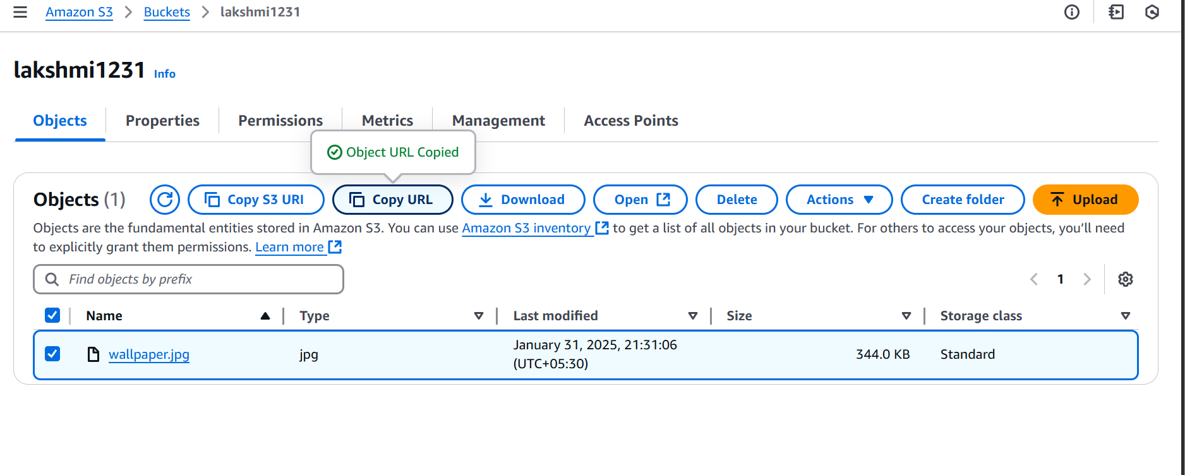

11.Get the output in the chrome screen while pasting the website URL.



KEY POINTS:

• **Access Control**: Always ensure that you manage your permissions carefully to prevent unauthorized access. Use IAM (Identity and Access Management) for granular control over users and groups.

• **Storage Class**: AWS offers various storage classes (e.g., Standard, Intelligent-Tiering, Glacier). Choose the one that fits your needs depending on cost and access frequency.

• **Versioning**: Enabling versioning will store all versions of your files, which can increase storage costs but is useful for data recovery.

**Output:**

• A New Bucket: You’ll successfully create a new storage container (bucket) in Amazon S3, with your chosen name and region.

• Configured Settings: The bucket will be set up with the right settings, such as permissions (who can access it) and versioning (if you want to keep multiple versions of files).

• Uploaded Files: You will be able to upload files into your bucket, which will be stored safely in the cloud.

• Security in Place: The bucket will have security settings that prevent unauthorized access, keeping your data safe.

• Ready for Use: Your bucket will be visible in the AWS console, and you can start using it to store and manage your files**.**